

**DevOps Tools**

Table of Contents

1

Table of Contents 2

1 Lab Details: 3

2 DevOps Tools: Guided Exercises 3

2.1.1 GIT –Problem Statement 3

Guided Exercise 1: 4

Guided Exercise 2: 6

Guided Exercise 3: 7

Guided Exercise 4: 9

# Lab Details:

You will be provided with the below DevOps Lab for practicing the guided exercise in this document.

1. Enroll for DevOps Tools - Practice Lab to practice these guided exercises.

# DevOps Tools: Guided Exercises

### GIT –Problem Statement

A leading training institute in India is planning to develop their Self Learning Portal. The proposed solution has been planned to develop in a DevOps environment. The project is under development and there is a module which allows learners to maintain their skill development plan. The functionality allows the learners to login and manage their learning schedule.

Since the application is being developed in a DevOps environment, the project needs to be updated to GIT repository as a part of software configuration management.

**Scope:**

You have been assigned the task of managing the builds on the Git Repository for continuous integration of the project along with fellow developers.

Given the project builds, you need to perform the following main tasks.

* Create a local repository for staging and committing files.
* Maintain the log of commits performed.
* Merge the commits locally before performing sync with the remote repository.
* Push your local repository update to GIT remote repository.

**Steps:**

1. Install, test and Configure GIT.

2. Initialize GIT local repository.

3. Create files in the Working directory (Local Repository).

4. Add files to staging area in the Repository.

5. Commit files to the repository.

6. Get information about the commit made to the repository.

7. Implement the command to add the data to remote repository.

8. Push data to remote repository.

Guided Exercise 1

**Estimated Completion Time:** 5 Minutes

**Steps to follow:**

**Step 1**

1. Copy the given LearningPortal.zip on your system, extract the zip file to any location and

Open the LearningPortal folder and right click and select GIT Bash. You will see the screen as provided in Fig 1.1 and 1.2.



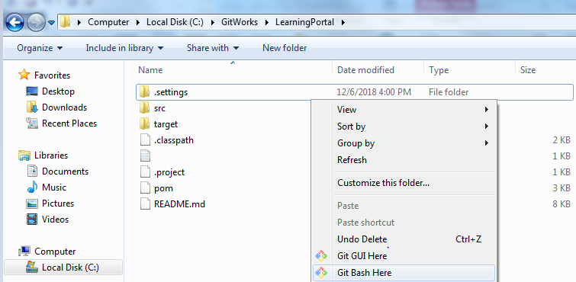

[ Fig 1.1]

**Step 2:** Test the environment. Refer Figure 1.2

**Solution:**

**Command: git –version**

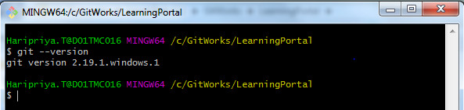

[Fig 1.2]

**Step 3:** Initializing GIT local repository and working with files in GIT environment

A. Check the current path and initialize Git. Refer Figure 1.3

**Solution:**

**Command: pwd , git init**



[Fig 1.3]

**Step 4:** Setting configuration

Set values for user name and email so that GIT can use this information to Identify

Users in the repository. Refer Figure 1.4

**Solution:**

**Command:**

* **git config -- all**
* **git config user.name “your-name”**
* **git config user.email “your-email”**

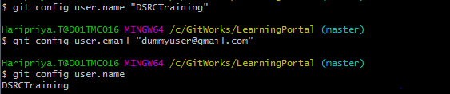

[Fig 1.4]

Guided Exercise 2:Working with files in GIT Environment

**Estimated Completion Time:** 10 Minutes

**Objective:** To add files from working area to staging area and commit these files to the Repository.

**Steps to follow:**

**Step 1:** Adding file’s from working directory to the Local Repository

Add Command To:

1. Navigate to the location where project is extracted. List the contents of the directory.

**Solution:**

**Command: ls –la**

Refer Figure 2.1

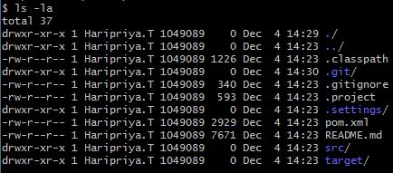

[Fig 2.1]

1. Get the status of the files.

**Solution:**

**Command: git status**

Refer Figure 2.2

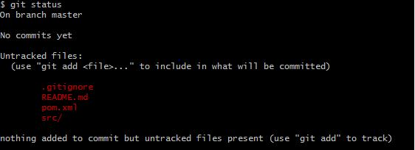

[Fig 2.2]

1. To add the java source files to the staging area, change to the folder where java files are existing and verify the current location. Refer Figure 2.3 and 2.4

**Solution:**

**Command: cd <<location>>**

**pwd**



[Fig 2.3]



[Fig 2.4]

1. Add all the files from src\main\java\com\in28minutes \springboot/web folder to staging area (index area of GIT) like shown in the Fig 2.6.

**Solution:**

**Command: git add .**

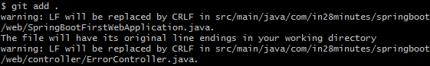

[Fig 2.5]

1. After adding all the files as per illustrated in Fig 2.5, the status will appear as shown in Fig 2.6. Verify the status.

**Solution:**

**Command: git status**

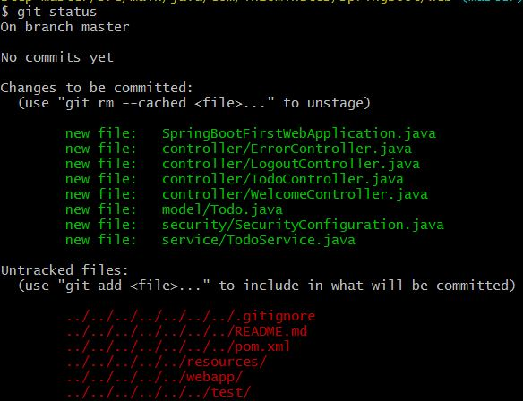

[Fig 2.6]

Guided Exercise 3:Viewing Repository History

**Estimated Completion Time:** 10 Minutes

**Objective:** To View commit History from the Repository

Steps to follow:

**Step 1:** The changes made to the source files are committed to the staging area.

Refer Figure 3.1

**Solution:**

**Command: git commit –m “message”**

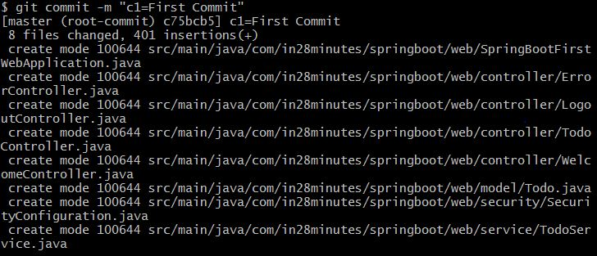

[Fig 3.1]

**Step 2:** Use the command to view all the commits made to the staging area. Refer Figure 3.2.

**Solution:**

**Command: git log**

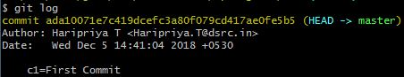

[Fig 3.2]

**Step 3:** Use command to view the commit information on each commit in a single line from the staging area. Refer Figure 3.3.

**Solution:**

**Command: git log --oneline**

C:\Users\haripriya.t\Pictures\GitPics\G1.JPG

[Fig 3.3]

**Step 4:** View the file information added to specific commit using commit 'SHA1 - hash value

File list (On your console the value may be different). Select any commit SHA1 hash value. Result shown in the Fig 3.4

**Solution:**

**Command: git show –pretty=” ”—name-only ada1007**

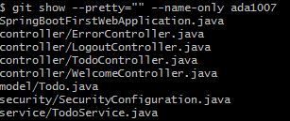

[Fig 3.4]

**Step 5:** Verify the status. Refer Figure 3.5

**Solution:**

**Command : git status**

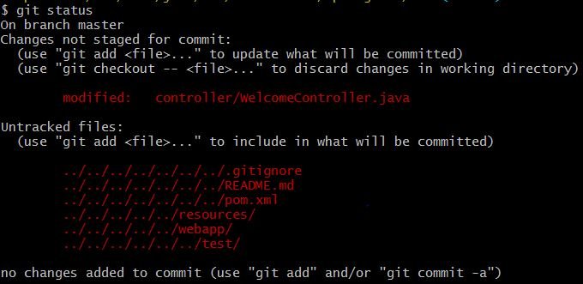

[Fig 3.5]

Guided Exercise 4:Adding Data to remote Repository

**Estimated Completion Time:** 5 Minutes

**Objective:** Synchronizing data with remote repository

Steps to follow:

**Step 1:**

* Log into GitLab with your Cognizant credentials to configure your repository <https://code.cognizant.com>
* Create a project named **cicd project** 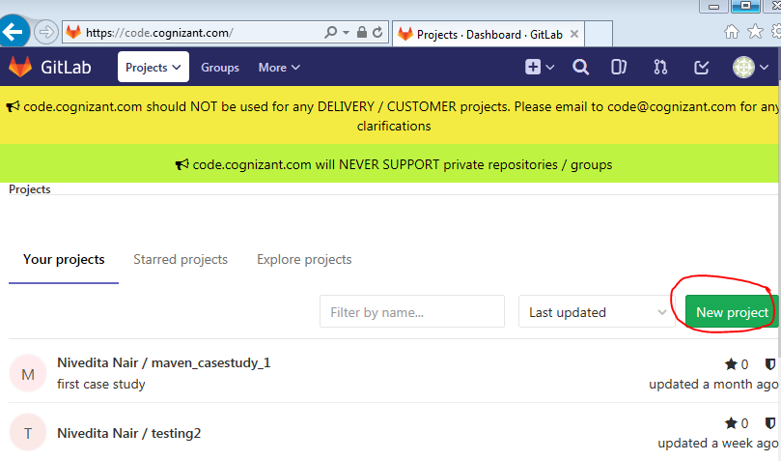

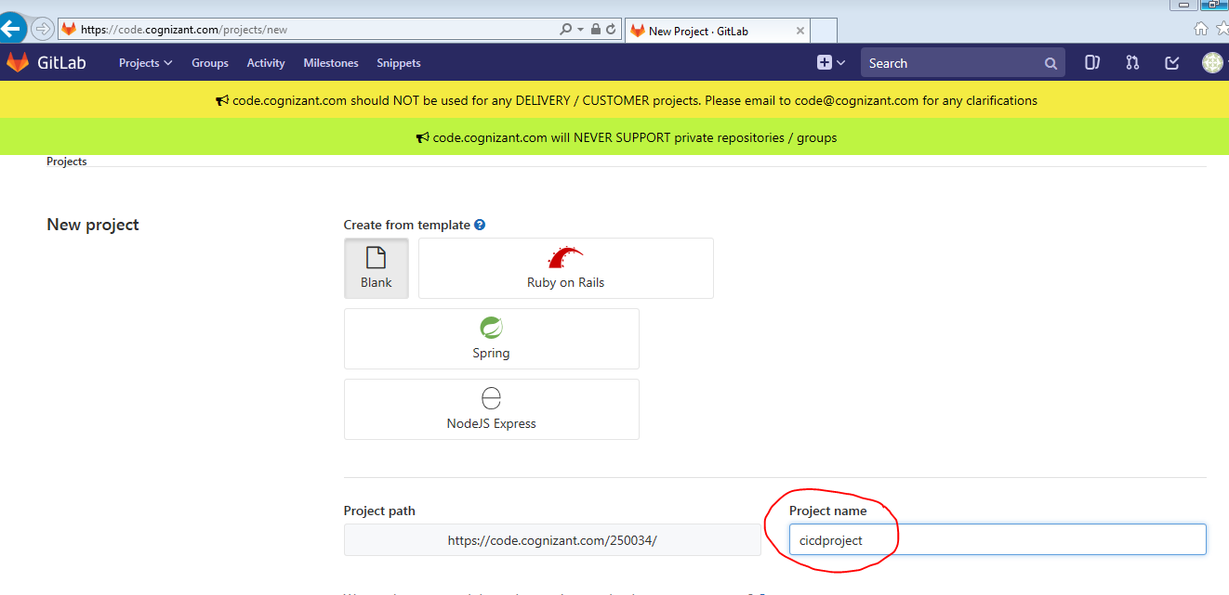

[Fig 1.5]

**Step 2:** Copy the GitLab project URL.  
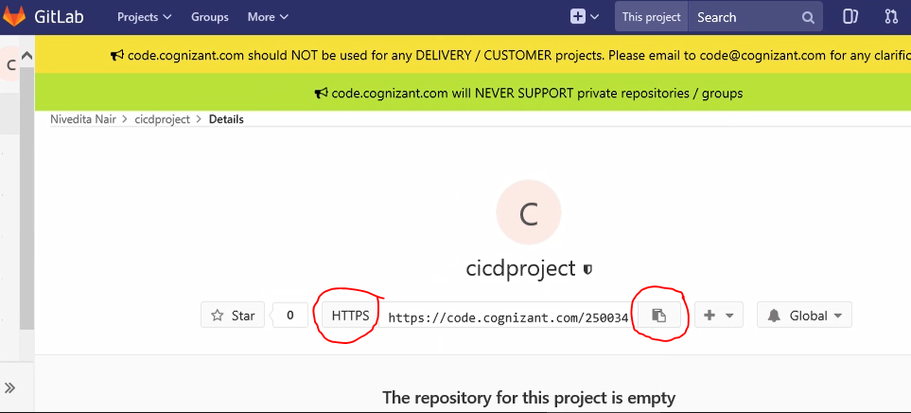

<https://github.com/DSRCTraining/LearningPortal.git> (Sample URL)

**Step 4:** Copy the existing Git Repository to a local file system.

Clone the repo in a new directory, at another location. Refer Fig 4.4

**Solution:**

**Command; git clone <<repo Name>>**

**C:\Users\haripriya.t\Pictures\GitPics\Git16.JPG**

[Fig 4.4]

**Step 5:** Specify the remote repository location to which the files needs to be submitted

**Solution:**

**Command: git remote add origin <<repo Name>>**

C:\Users\haripriya.t\Pictures\GitPics\Git17.JPG

[Fig 4.5]

Hint: use push command push data to remote repository (use –u option with push)

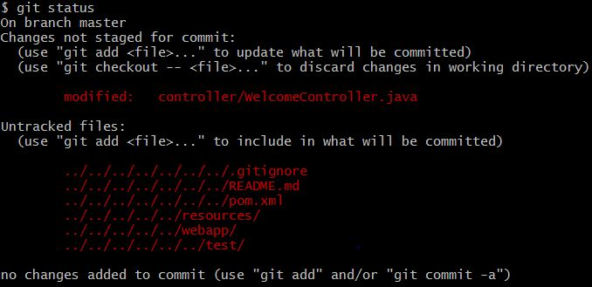

[Fig 4.6]

**Step 6:** Push the files to the remote repository.

**Solution:**

**Command: git push –u origin master**

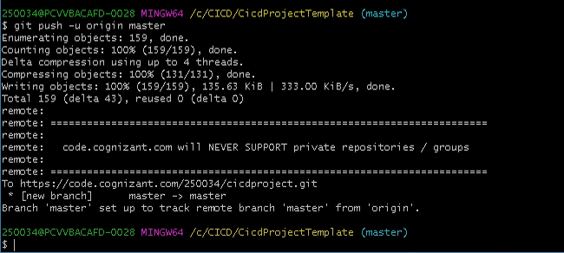

[Fig 4.7]

**Summary:**

You have learnt to install and configure GIT for DevOps Environment